Slide 1

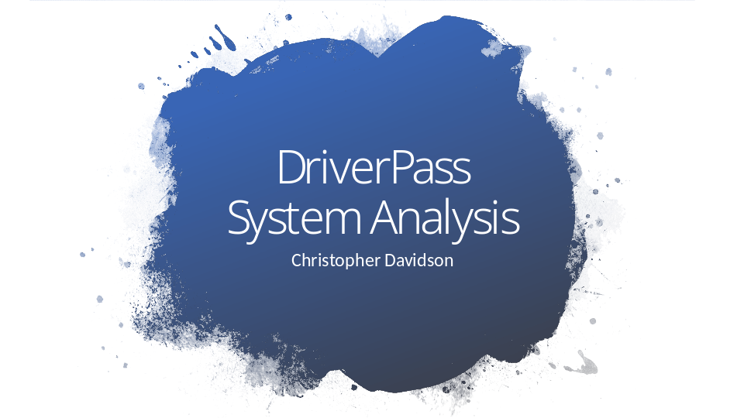

[No speaker notes required for this slide.]

Slide 2

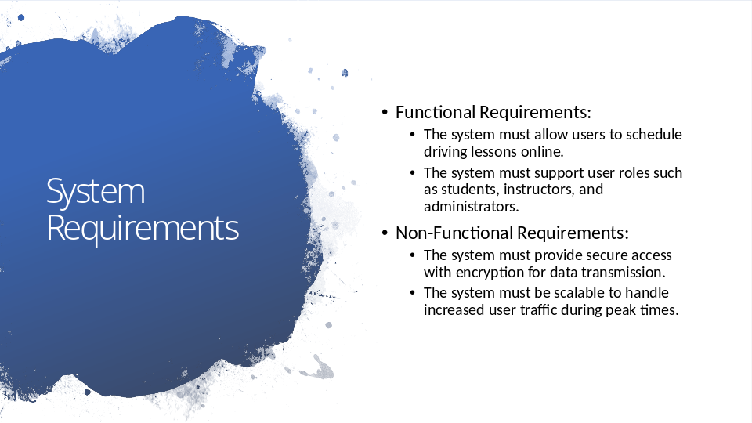

- Functional Requirements:
- The DriverPass system must allow users, particularly students, to schedule driving lessons online. It must also support different roles such as students, instructors, and administrators, each with their specific access levels. For instance, students can book lessons and track their progress, instructors manage schedules and leave feedback, and administrators oversee system security and account management​.
- Non-functional requirements:
- Ensure that the system remains secure and scalable. Security is crucial, with SSL/TLS encryption protecting sensitive data like payment information. The system will also be able to scale during peak times, like DMV test seasons, ensuring that 500 users can use the system simultaneously with no more than a 10% response time increase​.

Slide 3

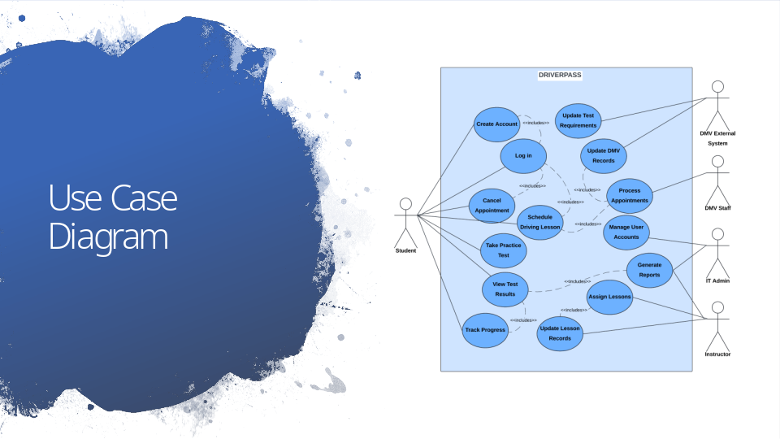

- The use case diagram highlights how different user types interact with the system. Students log in to schedule, cancel, or reschedule lessons and track their progress in both practice tests and driving sessions. Instructors manage their schedules and provide lesson feedback, while administrators control user accounts and system security. The DMV can update test requirements, ensuring the system stays up to date with regulations​​.

Slide 4

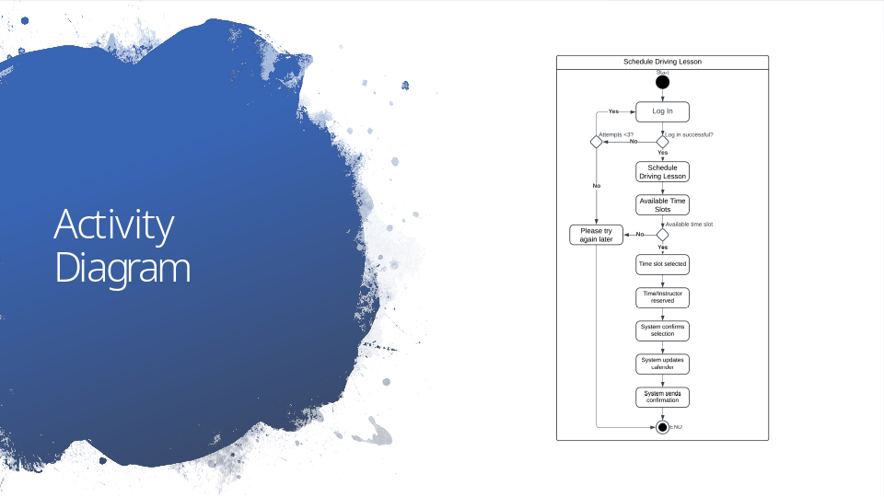

- This activity diagram illustrates the process of scheduling a driving lesson. The student logs in and chooses a lesson slot based on the instructor's availability. The system confirms the booking in real-time and sends a notification. If there are no available slots, the student is prompted to try again later. This ensures that the scheduling process is efficient and easy for students to navigate​.

Slide 5

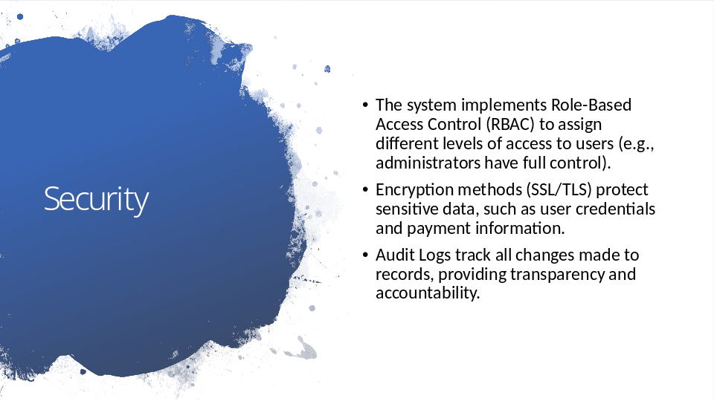

- The system uses Role-Based Access Control (RBAC) to assign access levels to different users. For example, students manage their bookings, instructors manage their schedules, and administrators have full system control. Additionally, Multi-Factor Authentication (MFA) is required for administrator logins, adding an extra layer of security. All data transmissions are protected using SSL/TLS encryption, ensuring that sensitive information, such as payment details, remains secure.
- To maintain transparency, audit logs will track all user actions, such as booking or canceling lessons. This allows administrators to monitor system activity and respond to any issues promptly​​.

Slide 6

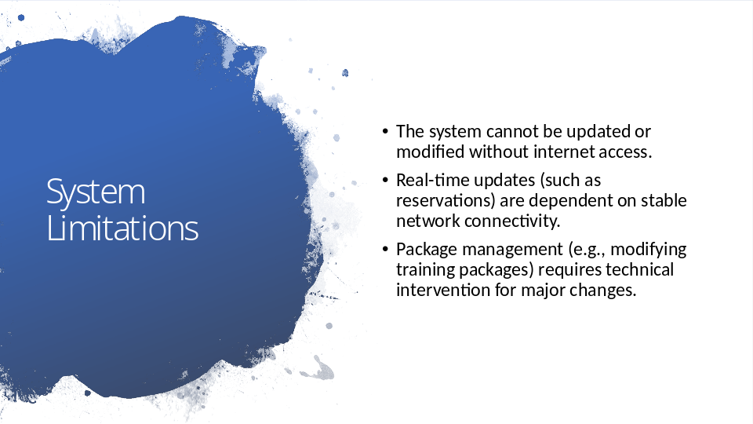

- The system relies on internet connectivity to function, so users will need a stable connection to book or manage lessons. In the event of a network failure, built-in retries and scheduled data syncs will ensure minimal data loss. Instructors can still take notes offline and sync them once back online.
- Modifying or adding training packages requires technical support, though administrators can easily enable or disable existing packages. This design prioritizes ease of use while providing flexibility for future system enhancements​​.

